**Disciplina:** Teste de Software

**Nome:** Vinicius Simões Vieira

**RA:** 2046474

1. **identifyExtremes**

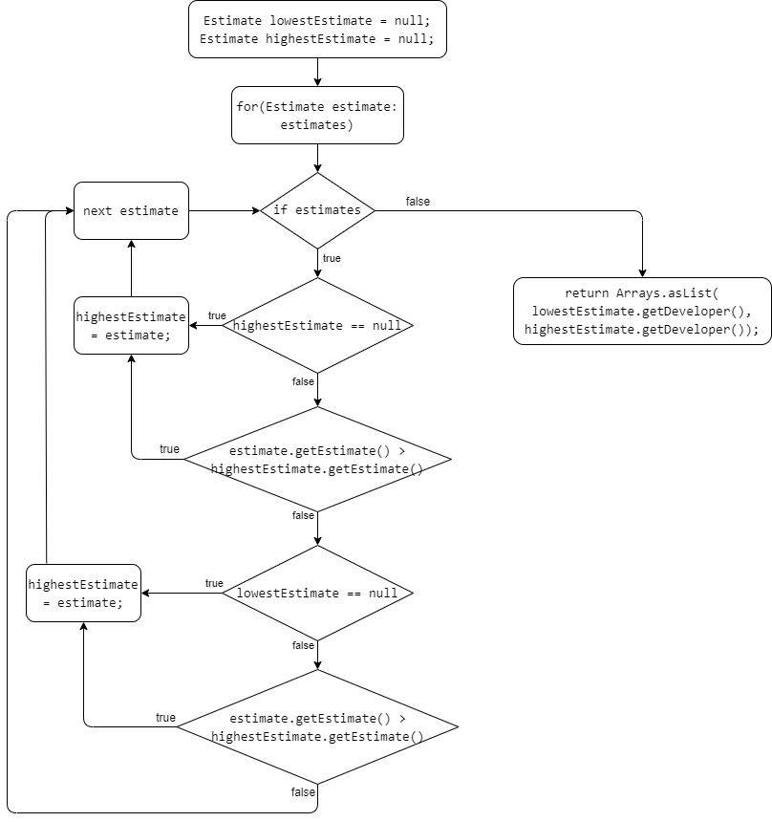

1. **substringsBetween**

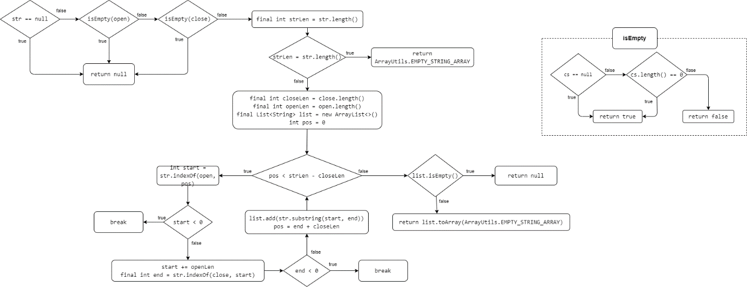

1. **identifier**

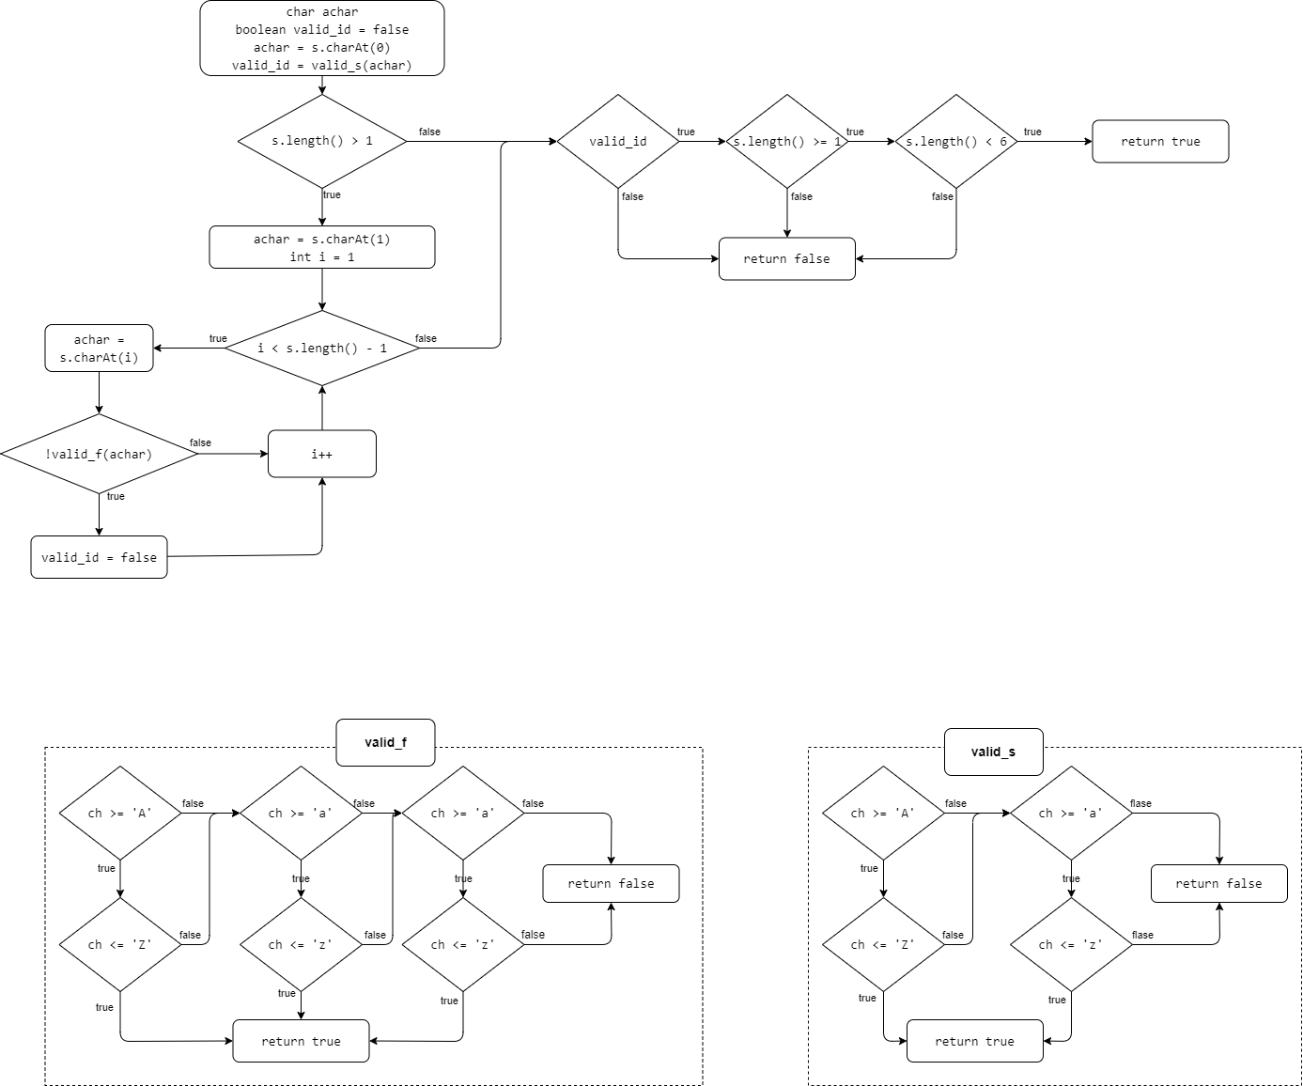

1. **add**

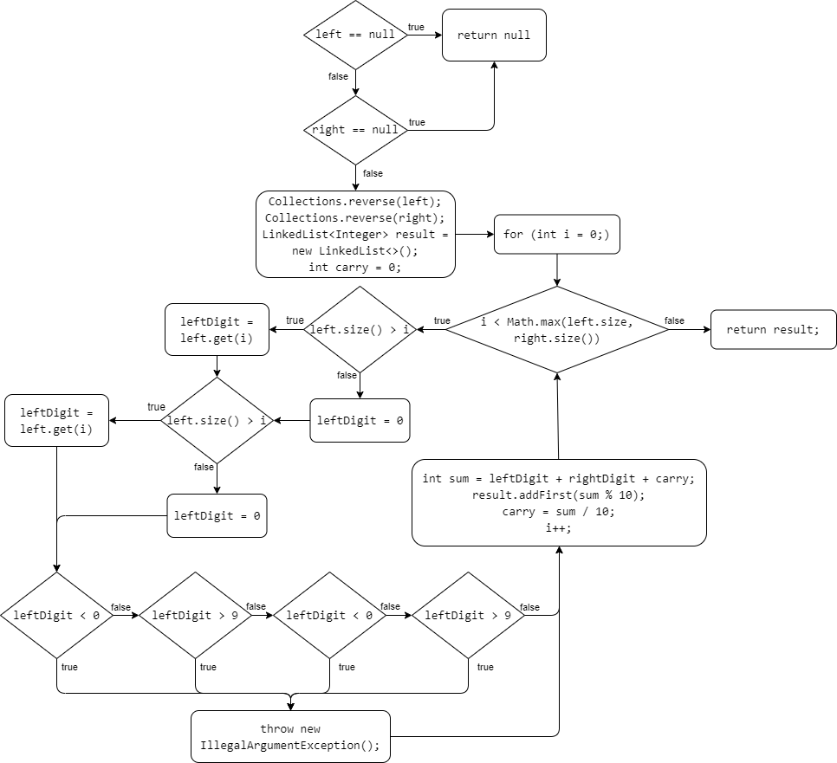

1. **countClumps**

